

Database Systems

Project Report

Blood Donation Compatibility Tracking System

BESE-30’B

Submitted to : Dr. Kamran

Submitted by:

NC Alisha Fatima

Introduction
The Blood Donation Compatibility Tracking System is a database-driven application designed to modernize and optimize the management of blood donors, recipients, and blood inventory in healthcare institutions. The system focuses on efficient data organization, real-time compatibility matching, and automation of safety checks such as donation eligibility and blood expiry monitoring. Hospitals frequently face difficulties when matching donors with recipients during emergencies, particularly when rare blood types are required or when stored blood units approach expiry. This system addresses these challenges by storing all relevant information in a relational database and using structured SQL logic to ensure rapid decision-making and accurate donor-recipient matching.
The project emphasizes data integrity, automation, and performance optimization. Instead of relying on manual searches or scattered digital records, the system provides a centralized platform where critical blood-related information is instantly accessible. A minimal user interface is implemented for essential data entry and query operations, while the core intelligence of the project resides within the database layer through the use of triggers, stored procedures, and relational constraints.

Background
Blood donation management in many developing regions continues to operate through informal communication channels such as messaging groups, class representatives, and verbal coordination. In emergency situations, these methods are slow, unstructured, and unreliable. Hospitals routinely struggle with locating compatible donors, identifying rare blood types, and ensuring that expired blood packets are not administered. The absence of automated tracking mechanisms often leads to delayed response, medical risk, and inventory wastage.
Modern healthcare systems demand digital solutions that ensure accuracy, traceability, and operational efficiency. A centralized database system offers a reliable solution by organizing donor and blood data in a structured format and enabling rapid queries based on blood group compatibility, availability, and eligibility rules. The shift from manual record-keeping to a structured data management system not only improves response time but also enhances the safety and reliability of medical operations.

Problem Statement
Current blood management practices are largely dependent on manual record-keeping or loosely structured digital files. When blood is required urgently, hospital staff must manually search records or contact multiple sources to identify suitable donors and check blood availability. This process is time-consuming, error-prone, and unreliable during critical moments.
The lack of automation results in:
- Delayed donor identification
- Difficulty in locating rare blood groups
- Accidental use of expired blood packets
- Violation of safe donation intervals
- Data redundancy and inconsistency
- Increased risk to patient health
The proposed system eliminates these weaknesses by introducing database-driven automation that intelligently manages blood inventory and donor records while ensuring data safety through constraints and validation rules.

Motivation
Our class representative frequently sends urgent messages requesting blood donations from students and asks for their blood types and availability manually. These requests are difficult to organize, often duplicated, and scattered across chat groups. This experience showed how inefficient manual tracking is and strongly motivated us to create a centralized database solution that can instantly show compatible donors and safe, available blood units.

Objectives
The main objective of this project is to develop an intelligent blood tracking database that enhances efficiency, safety, and accuracy. Along with a strong database foundation, the system also includes a functional web interface developed using PHP, HTML, and CSS to allow real-time interaction with the database. The system is designed to achieve the following objectives:
- Design a normalized relational database structure to store donor, recipient, and blood packet data efficiently
- Implement stored procedures to automatically find compatible donors based on blood group and location
- Enforce donation eligibility rules using database constraints and triggers
- Detect expired blood units automatically through scheduled database checks
- Create SQL views to highlight rare blood group availability
- Develop a PHP-based backend to process donor registration, recipient requests, and administrative operations
- Build an HTML and CSS-based user interface for data entry, search functions, and viewing results
- Provide analytical reporting support by exporting query and search results
- Maintain data consistency and eliminate redundant storage through normalization
These objectives ensure that blood donation management becomes faster, more reliable, and safer while providing a user-friendly interface for interaction with the system.

Scope of the Project
This project focuses on developing a structured and automated Blood Donation Compatibility Tracking System supported by a web interface.
The system will manage donors, recipients, blood inventory, and basic logistics in a centralized database environment. A PHP-based interface will be used for data entry, querying, and administrative control.

In Scope
- Donor and recipient data management
- Inventory storage and tracking
- Compatibility-based blood searching
- Basic shipment handling
- Admin control and monitoring
- Database automation for safety checks
- Web interface using PHP, HTML, and CSS
- Data validation and integrity enforcement
- Reporting on availability and expiry status

Out of Scope
- Laboratory testing systems
- Medical diagnosis features
- Payment or billing systems
- SMS/email integration
- Mobile and desktop apps
- AI-based prediction systems
- Hospital-wide software integration

Context and Source of Knowledge
The design and implementation of this project are based on a combination of academic study, practical data exposure, and real-world observation.
Academic knowledge was obtained from database course content including:
- Relational database design principles
- Normalization techniques
- SQL constraints, views, triggers, and stored procedures
- Transaction handling and query optimization
- Backend integration using PHP
To support real-world accuracy, official WHO blood compatibility guidelines and standard hospital blood bank workflows were studied to ensure correct compatibility rules, expiry management, and donor eligibility logic.

External Dataset Source
In addition to theoretical learning, real datasets were collected from Kaggle, a public data science platform that provides datasets for academic research and practice. These datasets were used to:
- Simulate realistic donor data
- Test inventory workflows
- Populate blood groups and donation history
- Validate compatibility queries
- Evaluate expiry management logic
The data was imported using MySQL Workbench Import Wizard, allowing structured CSV datasets to be converted directly into relational database tables.
To maintain flexibility and realism:
- The system also allows manual data entry through the web interface
- Records can be inserted, updated, and deleted dynamically
- The database supports testing under both synthetic and live input scenarios

Practical Exposure
This system was inspired by real-life incidents where blood requests were manually circulated through student groups. These informal methods are inefficient, unstructured, and unreliable.
From a practical standpoint, the project bridges the gap between:
- Classroom database concepts
- Real hospital workflows
- Emergency response needs
The goal was to transform a manual real-world process into a structured automated solution using database principles.

System Requirements

Functional Requirements
- Donor Management
  - Maintain detailed donor profiles (age, blood type, location, etc).
- Recipient & Request Handling
  - Store recipient details (required blood type, urgency, request date).
- Blood Inventory Management
  - Insert, update, and track blood packets with ID, type, collection date, expiry, and storage location.
  - Isolate, or remove expired packets.
- Blood Shipment Management
- Create shipments for requests and assign drivers.
- Compatibility Engine
  - Perform automated compatibility checks.
  - Suggest optimal matches.
- Reporting & Analytics
  - Generate reports for rare blood availability, inventory status, donor activity, and request fulfillment.

Non-Functional Requirements
- Accuracy & Integrity
  - Enforce validation, referential integrity, and transactional consistency.
- Reliability & Availability
  - Support 24/7 operation with minimal downtime.
- Performance
  - Execute matching, and inventory queries within seconds.
- Usability
  - Provide a clean, fast, emergency-friendly interface.
- Scalability & Maintainability
  - Modular design allowing integration with hospital systems and future expansions.

Key Database Features:
System Analysis

1. Automatic Inventory Creation on Successful Screening
Trigger: trg_donation_passed
Description:
When a donation's screening_status changes from anything → Passed, the system automatically inserts a new blood inventory record.
Key Behaviors:
- Auto-generates inventory entry linked to the donation.
- Sets storage_date = current date.
- Sets expiry_date = +42 days.
- Sets status to Available.
- Prevents manual errors and ensures instant inventory update.

2. Automatic Expiry Management for Blood Packets
Triggers:
- trg_auto_expire_inventory_ins (before insert)
- trg_auto_expire_inventory_upd (before update)
Description:
Ensures no expired item ever remains incorrectly marked as Available.
Key Behaviors:
- If expiry_date < current date, status is forcibly set to Expired.
- Works on both new additions and updates.
- Maintains data integrity and ensures safe usage in emergency decisions.

3. Prevent Invalid Reservations of Blood Units
Trigger: trg_prevent_invalid_reserve
Description:
Prevents reserving blood packets that are no longer valid for use.
Key Behaviors:
- Blocks reservation if item is already:
  - Used
  - Expired
  - Already Reserved
- Raises SQL error (SIGNAL SQLSTATE '45000').
- Ensures correctness in allocation workflows.

4. Inventory Search Procedure (Real-Time Lookup)
Procedure: search_inventory(btype)
Purpose:
Provides fast and filtered access to available units of a specific blood type.
Key Behaviors:
- Returns only packets with status = Available.
- Supports matching during emergencies.

5. Automated Expiry Update Procedure
Procedure: mark_expired_inventory()
Purpose:
A maintenance routine to efficiently batch-update expired items.
Key Behaviors:
- Marks all items past expiry_date as Expired.
- Efficient weekly/daily cron execution.
- Guarantees accurate stock availability reports.

6. Shipment Creation Procedure
Procedure: create_shipment_proc()
Purpose:
Standardizes how blood shipments are created in the database.
Key Behaviors:
- Automatically inserts shipment record with current date.
- Captures driver, facility, and quantity.
- Prevents missing metadata and improves traceability.

Key Backend Logic & Database Interaction Features

Feature 1: Unified User Registration System
Functions: registerUser()
Purpose:
Handles creation of Users, Donors, and Recipients in a single transaction.
Key Behaviors:
- Generates secure, unique IDs for all accounts.
- Stores hashed passwords (PASSWORD_DEFAULT).
- Inserts role-specific profiles:
  - Donor: age, CNIC, blood group, location, phone, availability.
  - Recipient: blood group, urgency, required date, location.
- Auto-rollbacks on any failure to maintain data integrity.

Feature 2: Secure Multi-Role Login
Function: loginUser()
Purpose:
Authenticate users and ensure correct role-based access.
Key Behaviors:
- Verifies credentials using secure password hashing.
- Enforces expected role (e.g., only recipients can access recipient pages).
- Initializes session data (user_id, role, and profile name).
- Retrieves display name from donor or recipient tables dynamically.

Feature 3: Session Termination / Logout
Function: logoutUser()
Purpose:
Ensures safe logout by clearing all session data and destroying the session.

Feature 4: Donation Creation
Function: createDonation()
Purpose:
Allows donors to log donations if screening already Passed.
Key Behaviors:
- Generates unique donation ID.
- Inserts donation record with screening status.

Feature 5: Create Blood Request
Function: createRequest()
Purpose:
Allows recipients to request blood from inventory.
Key Behaviors:
- Generates unique request ID.
- Stores request details (blood type, quantity, date needed, facility, urgency).
- Defaults request_date to current date.

Admin & Staff Management Features

Feature 6: Employee/Donor Assignment Management
Functions:
- assignEmployeeToDonor()
- removeEmployeeAssignment()
- adminGetDEAssignments()
Purpose:
Enable admin to assign donor relations to specific staff.
Key Behaviors:
- Creates/Deletes mapping entries in the de (Donor–Employee) table.
- Returns full join listing of employee–donor assignments.

Feature 7: Administrative Lookups
Functions:
- adminGetAllEmployees()
- adminGetAllDonors()
- adminGetAllUsers()
- adminGetAllDonations()
- adminGetAllRequests()
- adminGetStock()
Purpose:
Provide admin dashboard data for full oversight.
Key Behaviors:
- Retrieves full datasets of employees, donors, users, donations, requests, stock.
- Automatically includes relational data (e.g., names, blood group, quantities).
- Sorted for dashboard readability.

Public Search & User-Specific Records

Feature 8: Public Donor Search
Function: findDonor()
Purpose:
Allow the public or staff to search donors by blood group and location.
Key Behaviors:
- Filters by exact blood type and approximate location.
- Returns phone number for contact.

Feature 9: Donor Personal Donation History
Function: getUserDonations()
Purpose:
Show donors their past donations.
Key Behaviors:
- Returns date, quantity, and screening status.
- Sorted by most recent.

Feature 10: Recipient Personal Request History
Function: getUserRequests()
Purpose:
Show recipients all blood requests made by them.
Key Behaviors:
- Returns blood type, quantity, required date, and status.
- Sorted by most recent.

Feature 11: Admin Donation Retrieval
Function: adminGetDonationsByStatus()
Purpose:
- Fetch donation records with optional filtering by screening status.
- Joins donor table to retrieve donor names.
- Results ordered by latest donation first.

Feature 12: Donation Status Update + Auto-Inventory Creation
Function: updateDonationStatus()
Purpose:
- Updates donation screening status with transactional safety.
- If a donation is marked Passed, system automatically:
  - Retrieves blood details
  - Generates inventory ID
  - Calculates expiry (+42 days)
  - Inserts a new blood_inventory record with status Available.
- Handles rollback on failure.
This implements the “Trigger — donation passed → insert inventory row” logic.

Feature 13: Retrieve Available Blood Inventory
Function: getAvailableInventory()
Purpose:
- Returns unexpired, available inventory matching a blood type.
- Orders packets by earliest expiry to ensure optimal utilization (FIFO).

Feature 14: Safe Inventory Reservation
Function: reserveInventory()
Purpose:
- Transactionally reserves an inventory packet only if its status = Available.
- Automatically rejects if packet is already Used/Reserved/Expired.
- Updates the request status to Accepted.
- Logs an alert for traceability.
This supports the trigger rule “prevent reserving invalid items.”

Feature 15: Shipment Creation Workflow
Function: createShipmentForRequest()
Purpose:
- Generates shipment ID and inserts a shipment entry.
- Reserves inventory items if provided.
- Updates the request state to Approved.
- Supports logistics management for dispatching blood packets.

Feature 16: Expired Inventory Detection
Function: getExpiredInventory()
Purpose:
- Retrieves all inventory entries past their expiry date.
- Used for automated cleanup or report generation.

Feature 17: Delete Expired Inventory
Function: deleteExpiredInventoryItem()
Purpose:
- Removes expired inventory entries from the database.
- Supports cleanup routines or periodic maintenance scripts.

All Database Parts

Conceptual Design
- Identification of key entities: Donor, Recipient, Blood Inventory, Alerts.
- Modeling relationships using ER diagrams.

Logical Design
- Normalization up to 3NF to eliminate redundancy.
- Primary, candidate, and foreign key selection.
- Relationship mapping (one-to-many).

Physical Design
- Implementing CREATE TABLE statements.
- Assigning data types, constraints, and indexes.
- Defining triggers, views, and stored procedures.

Implementation
- Inserting test records.
- Executing compatibility stored procedures.
- Trigger-based automatic expiry updates.
- View generation for rare blood types.

Testing
- Running SELECT, JOIN, UPDATE queries.
- Evaluating donor availability.
- Checking expiry updates.

Analytics
- Generating graphs showing:
  - Blood type distribution.
  - Rare type frequency.
  - Age group donation frequency (scatter/dotted).

Documentation
- Full proposal, ERD, schema, queries, and output evidence.

Entities Description
These are the entities used in this system:
- Donor
Stores personal details and donation availability of individuals who donate blood.
- Employee
Contains staff information responsible for managing donor records and donation processes.
- DE (Donor–Employee)
Associative entity linking donors to the employees who handled their registration or donation.
- Blood_Donation
Records each donation event including date, blood type, and quantity collected.
- Blood_Inventory
Stores blood packets along with storage date, expiry date, quantity, and current status.
- Blood_Shipment
Tracks transportation of blood inventory to medical facilities, including shipment date and quantity.
- Driver
Stores personal and contact information of blood transport drivers.
- Medical_Facility
Represents hospitals and clinics requesting or receiving blood supplies.
- MD (Medical Facility–Driver)
Associative entity linking medical facilities with drivers assigned for deliveries.
- Request
Logs blood requests including request date, type required, and quantity needed.
- Recipient
Stores details of individuals requiring blood transfusions, including urgency and required date.
- Alerts
Logs system-generated warnings such as low stock levels or expiring blood units.

Database Design Approach
The database will be designed using ERD modeling to identify relationships between entities. The relationships include:
- A single donor can be linked to multiple blood packets in the inventory.
- A recipient receives blood based on compatibility logic rather than direct foreign keys.
- Alerts are generated automatically by triggers and do not map to a single entity directly.
Normalization will be performed to the Third Normal Form (3NF) to avoid redundancy and maintain integrity.

Planned SQL Components

Conceptual Design

1. Strong Entities (Primary Entities)
These entities exist independently:

1. Donor
Attributes:
- donor_id (PK)
- cnic
- name
- age
- gender
- blood_group
- location
- last_donation_date
- availability
- phone_number

2. Recipient
Attributes:
- recipient_id (PK)
- name
- blood_group
- location
- urgency
- required_date

3. Employee
Attributes:
- employee_id (PK)
- cnic
- first_name
- last_name
- role
- address
- phone_number
- date_joined

4. Driver
Attributes:
- driver_id (PK)
- cnic
- first_name
- last_name
- phone_number
- vehicle_no

5. Medical_Facility
Attributes:
- facility_id (PK)
- facility_name
- address
- phone_number
- contact_person

6. Users
Attributes:
- user_id (PK)
- username
- password_hash
- role
(This entity maps application logins.)

2. Weak Entities
A weak entity depends on a strong entity for identification.

7. Alerts (weak entity)
Why weak?
- "alert_id" is VARCHAR but alerts logically depend on some event or system state.
- In many systems, alerts do not make sense without the system they belong to.
Attributes:
- alert_id (partial key)
- alert_message
- date_issued
Weakness justification: Alerts cannot exist independent of system entities; they depend on certain triggers (donor shortage, expired blood, etc.).

3. Associative Entities (Bridge / Intersection Tables)

8. DE (Donor–Employee)
This is clearly an M:N associative entity:
A donor can be handled by many employees.
An employee can handle multiple donors.
Associative table: DE (donor_id, employee_id)
Both are FK + together form composite PK.

4. Regular (Non-Weak) but Dependent Entities
These are not weak but depend on others through foreign keys.

9. Blood_Donation
Attributes:
- donation_id (PK)
- donation_date
- blood_type
- blood_quantity_ml
- screening_status
- donor_id (FK → Donor)
Relationship:
Donor (1) —— (M) Blood_Donation
Participation:
- Donor: partial
- Blood_Donation: total (every donation must belong to a donor)

10. Blood_Inventory
Attributes:
- inventory_id (PK)
- donor_id (FK → Donor)
- blood_type
- blood_quantity_ml
- storage_date
- expiry_date
- status
Relationship:
Donor (1) —— (M) Blood_Inventory
Participation:
- Donor: partial
- Inventory: total

11. Request
Attributes:
- request_id (PK)
- request_date
- quantity_requested_ml
- type_requested
- recipient_id (FK → Recipient)
- facility_id (FK → Medical_Facility)
- required_date
- status
Relationships:
Recipient (1) —— (M) Request
Medical_Facility (1) —— (M) Request
Participation:
- Request is totally dependent on both entities.

12. Blood_Shipment
Attributes:
- shipment_id (PK)
- shipment_date
- quantity_ml
- driver_id (FK → Driver)
- facility_id (FK → Medical_Facility)
- status
Relationships:
Driver (1) —— (M) Blood_Shipment
Medical_Facility (1) —— (M) Blood_Shipment
Participation:
- Blood_Shipment: total on both sides

Multi-Valued Attribute (Requirement #3)

Donor: phone_number can be multi-valued
A donor may have multiple phone numbers.
To model this properly in conceptual ERD:
DonorPhone (multi-valued attribute)
- phone_number
- donor_id
Representation: double oval in ERD.

ERD
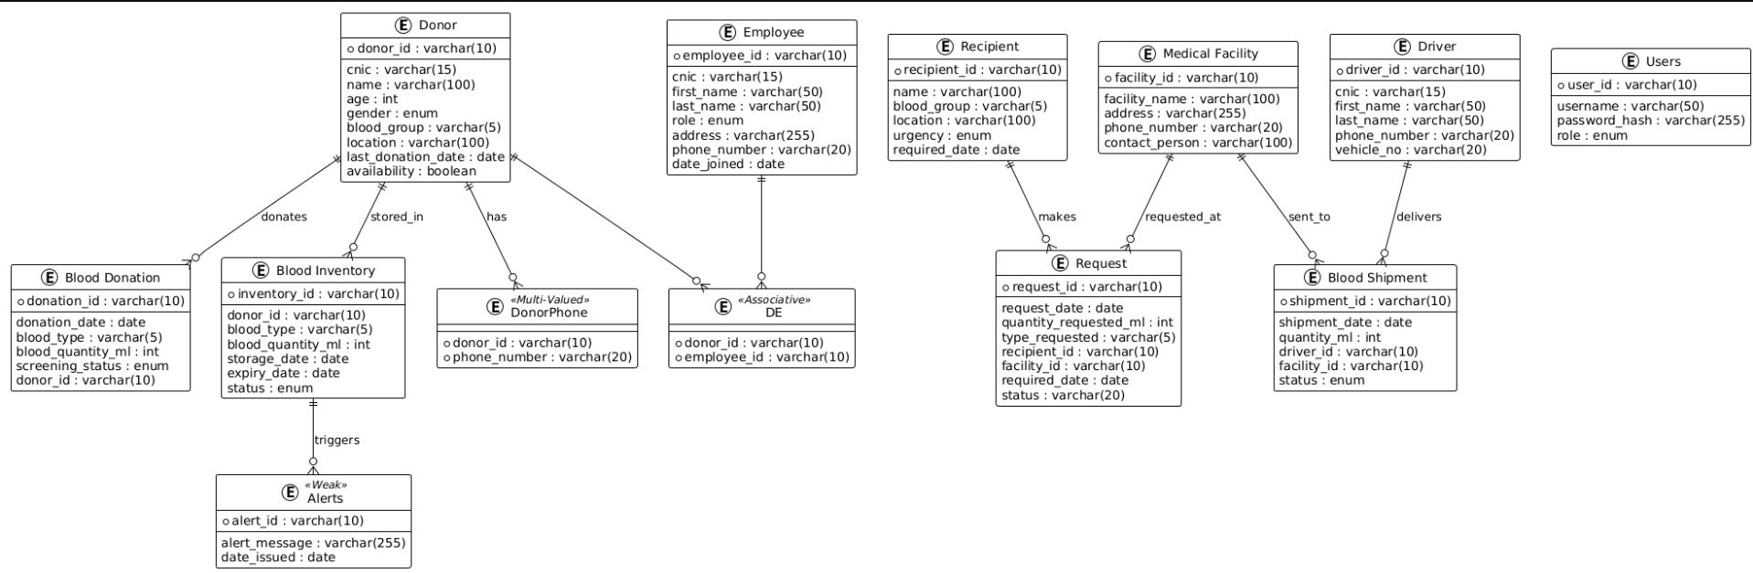
Logical Design

Identification of Keys

a. Primary Keys
List only PK attributes:
- Donor(donor_id)
- Blood_Donation(donation_id)
- Blood_Inventory(inventory_id)
- Alerts(alert_id)
- Employee(employee_id)
- DE(donor_id, employee_id) → Composite PK
- Recipient(recipient_id)
- Request(request_id)
- Medical_Facility(facility_id)
- Driver(driver_id)
- Blood_Shipment(shipment_id)
- Users(user_id)

b. Foreign Keys
- Blood_Donation.donor_id → Donor(donor_id)
- Blood_Inventory.donor_id → Donor(donor_id)
- Alerts.inventory_id → Blood_Inventory(inventory_id)
- DE.donor_id → Donor(donor_id)
- DE.employee_id → Employee(employee_id)
- Request.recipient_id → Recipient(recipient_id)
- Request.facility_id → Medical_Facility(facility_id)
- Blood_Shipment.driver_id → Driver(driver_id)
- Blood_Shipment.facility_id → Medical_Facility(facility_id)

c. Composite Keys
Only one composite key exists:
- DE(donor_id, employee_id)
This is because associative entities require a combination of both FKs as a primary key.

d. Derived Attributes
These do not need to be stored in tables but may be calculated:
1. Donor availability can be computed based on last_donation_date.
2. Inventory status can be derived by comparing expiry_date with today.

e. 3NF Normalization Justification
All relations are in 3NF because:
1. All attributes are atomic (no repeating groups → 1NF).
2. Every non-key attribute fully depends on the whole primary key (2NF).
3. There are no transitive dependencies (non-key attributes depending on other non-key attributes → 3NF).
4. Associative and weak entities are properly separated to remove redundancy.
As part of the logical design process, the original dataset was first imported and organized into separate tables using Excel. Each Excel sheet represented a potential entity (such as Donor, Blood Donation, Blood Inventory, Employee, Driver, Medical Facility, Recipient, Request, etc.). These raw tables often contained data redundancies and repeated attributes.
To ensure proper normalization, each dataset table was analyzed for dependencies and then decomposed step-by-step into 1NF, 2NF, and finally 3NF while preserving functional dependencies. This process helped eliminate partial and transitive dependencies, identify primary keys, foreign keys, and associative entities, and produce a clean, fully normalized relational schema. The final 3NF structure forms the basis of the relational schema presented in this report.
Example:
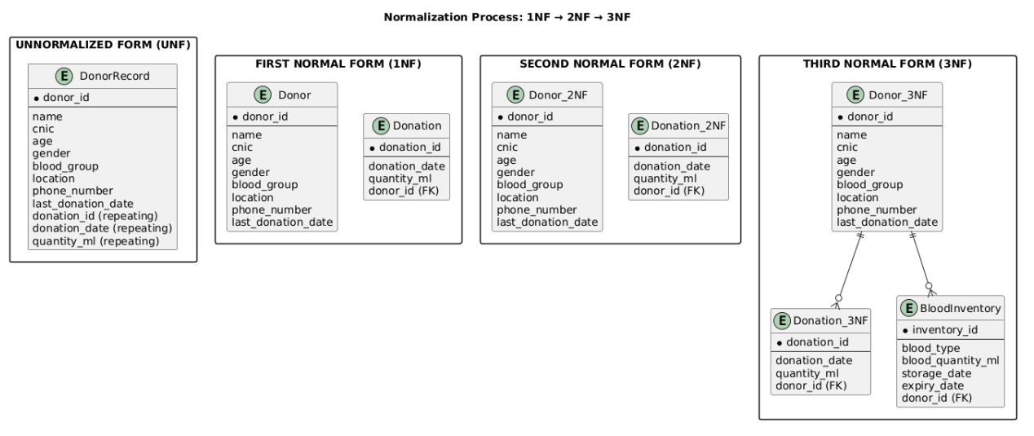

Graphs and Analytics
After running queries, the resulting data will be exported to graphing tools such as Excel or Python plotting libraries. The graphs will illustrate:
- Distribution of blood groups (bar graph)
- Percentage of rare blood types available (pie chart)
- Weekly or monthly expiry counts (line graph)
- Scatter plot (dotted graph)
These visual results strengthen report analysis.
Use Case Diagram:
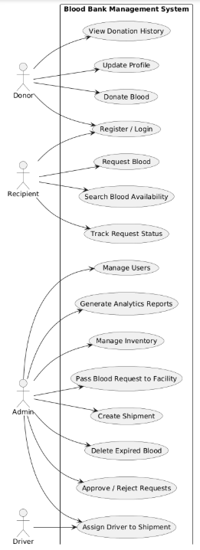

Sequence Diagram for Donor:
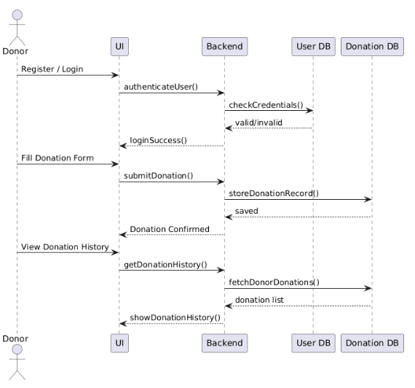
Sequence Diagram for Recipient:
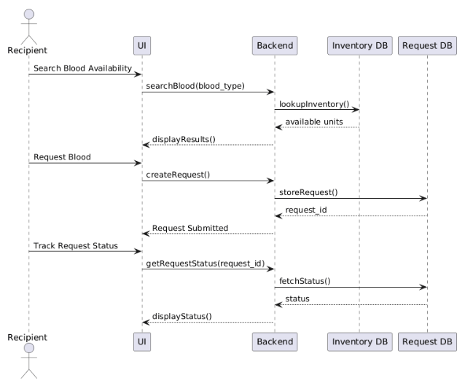

Sequence Diagram for Admin:
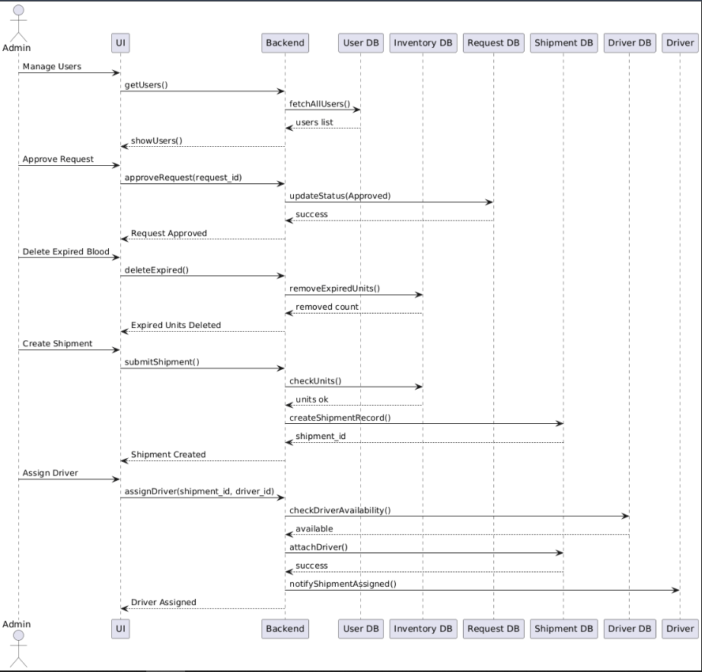
Activity Diagram for Donor:
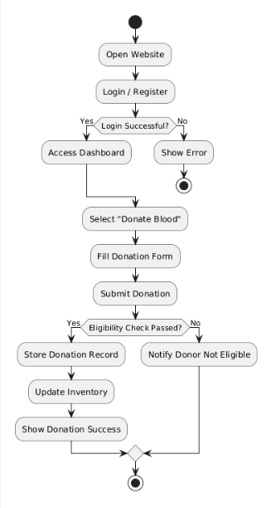
Sequence Diagram for Recipient:
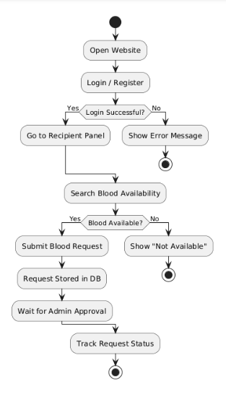
Sequence Diagram for Admin:
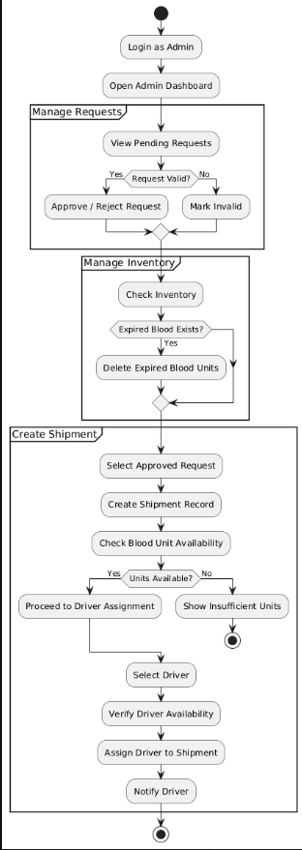
Context Diagram L1:
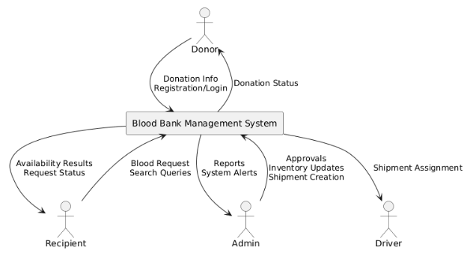
L2: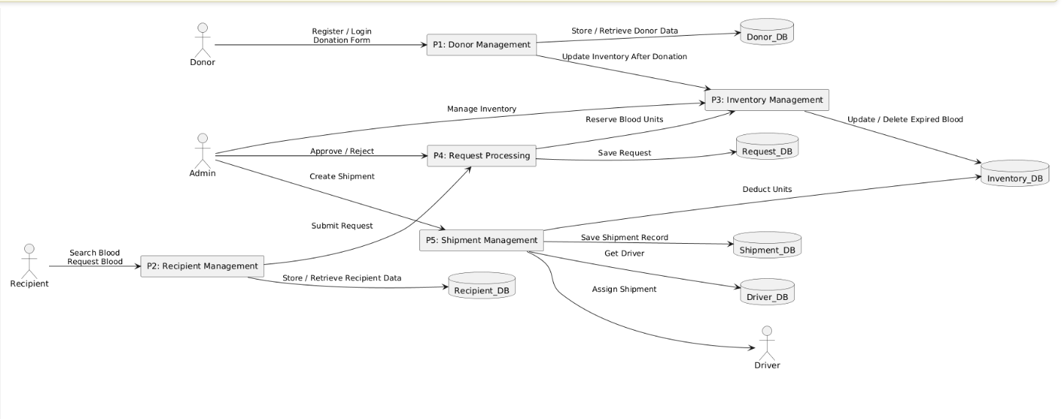
Class Diagram:
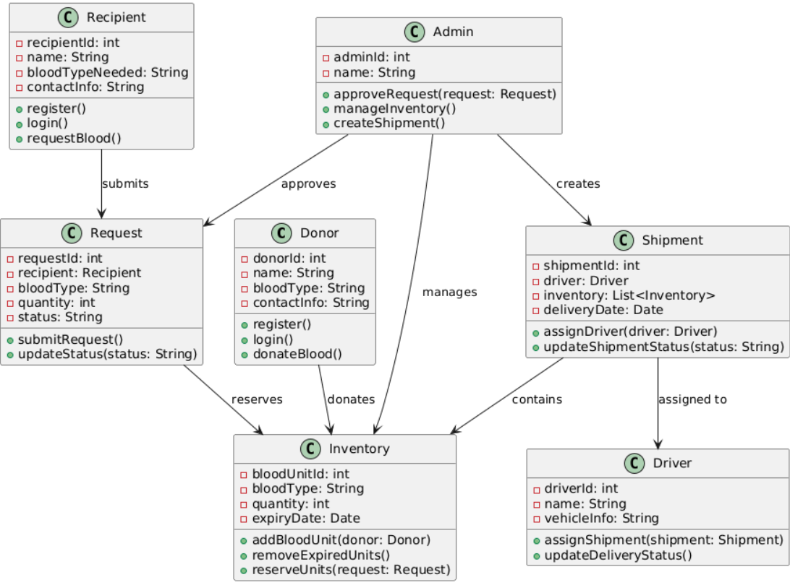
Physical Database Implementation
Tables Description:
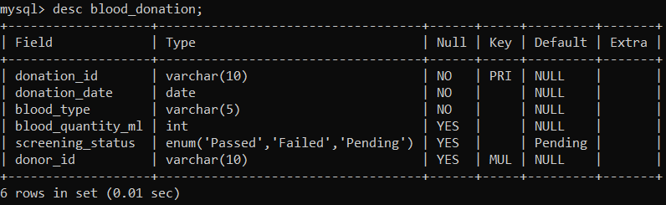
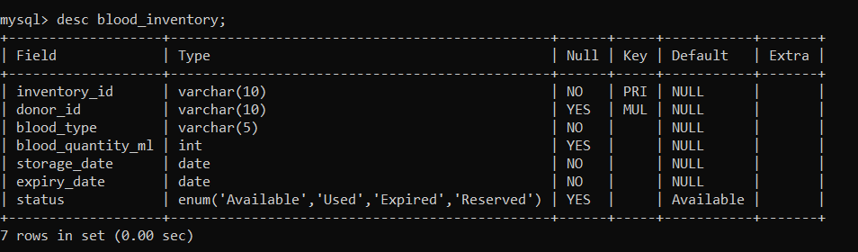
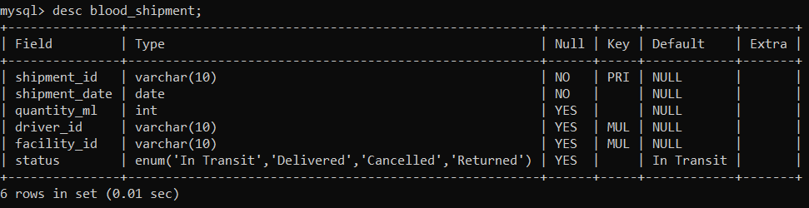
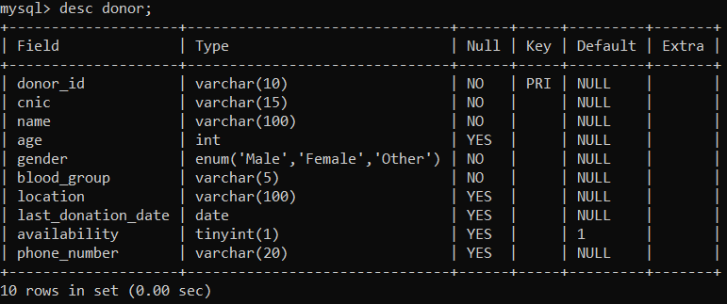
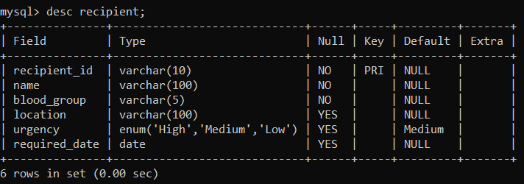
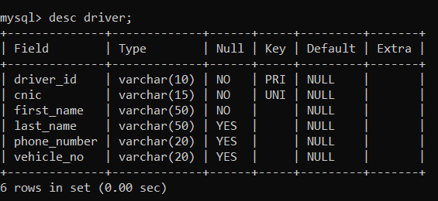
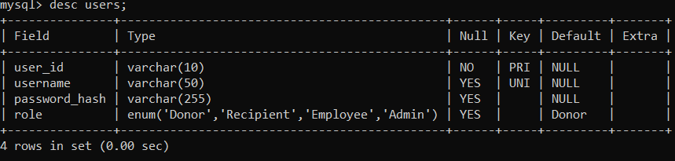
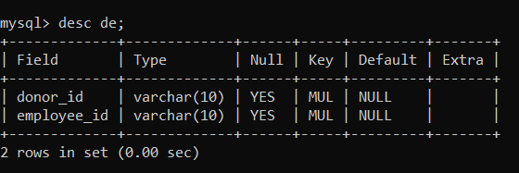
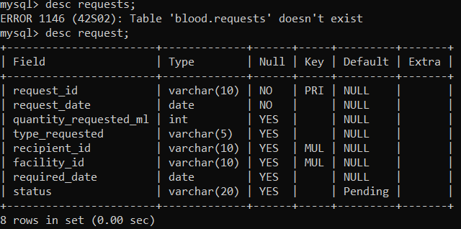
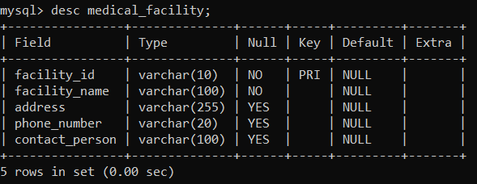
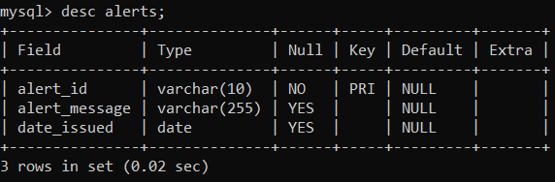

Triggers and Stored Procedures:
Trigger 1: when a donation moves to Passed insert an inventory row
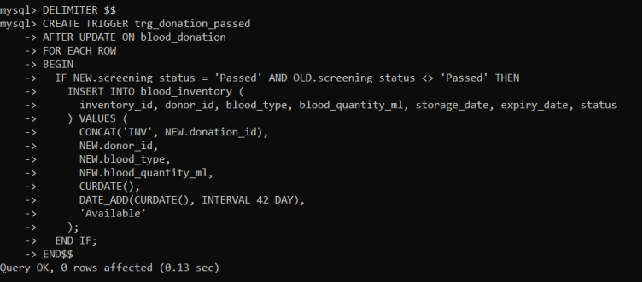
Trigger 2: auto-mark inventory as Expired when expiry_date is in the past
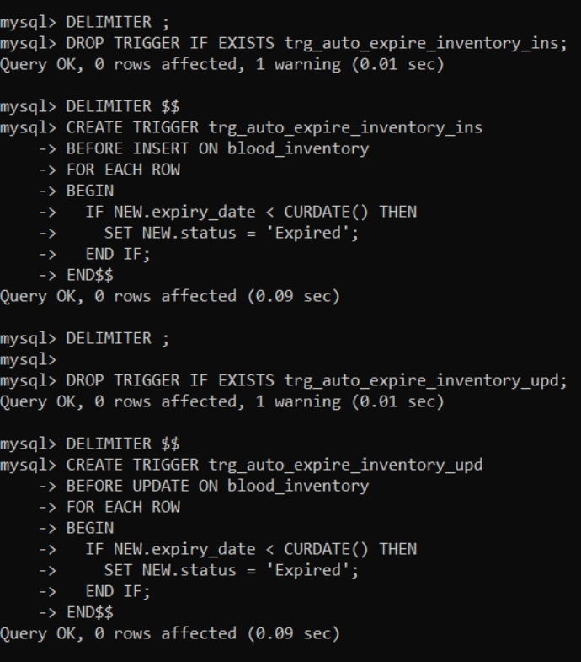
Trigger 3: prevent reserving items that are already Used/Expired/Reserved
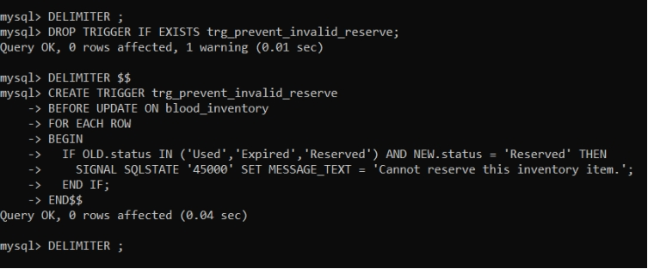
Procedure 1: Search inventory by blood type
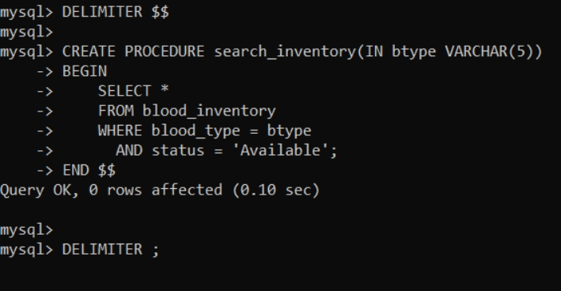
Procedure 2: Batch update expired items
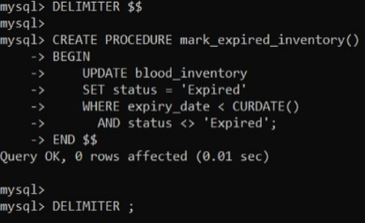
Procedure 3: Create shipment
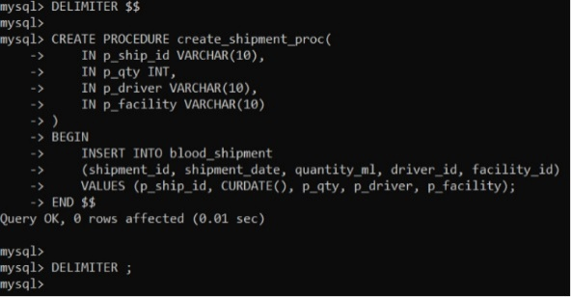
Transaction
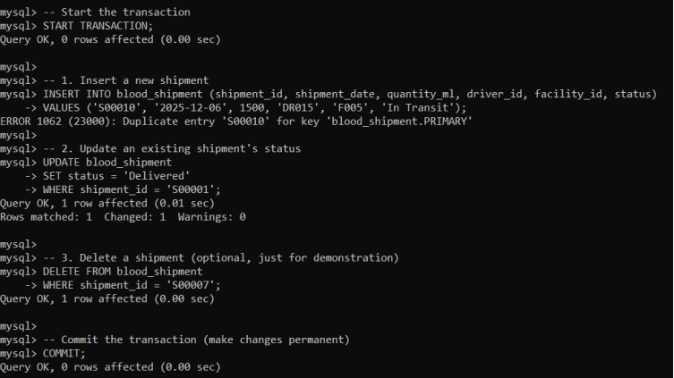
Before
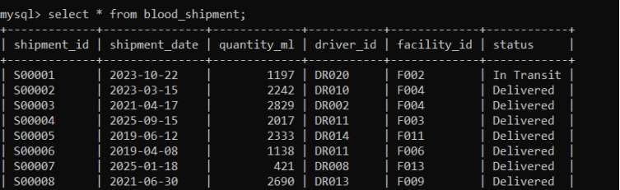
After
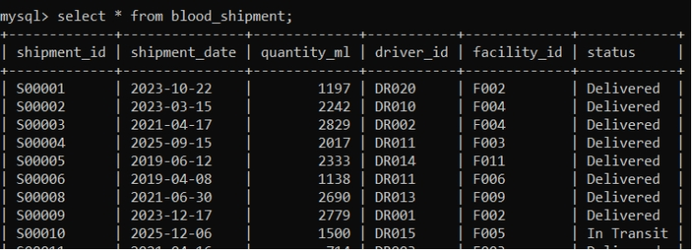
Example Testing:
START TRANSACTION;
-- Insert a new shipment with a unique shipment_id
INSERT INTO blood_shipment (shipment_id, shipment_date, quantity_ml, driver_id, facility_id, status)
VALUES ('S00101', '2025-12-06', 1500, 'DR015', 'F005', 'In Transit');
-- Update an existing shipment's status
UPDATE blood_shipment
SET status = 'Delivered'
WHERE shipment_id = 'S00012';
-- Delete a shipment (optional)
DELETE FROM blood_shipment
WHERE shipment_id = 'S00005';
COMMIT;
Query Requirements
Some Admin Functions:
  - Fetch recipient information
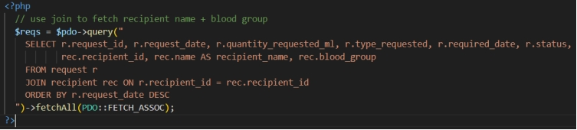
  - Delete selected expired items:
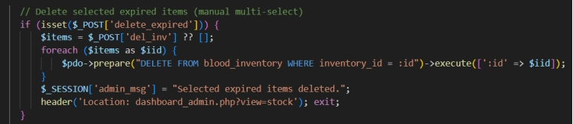
  - Reserve inventory for request:
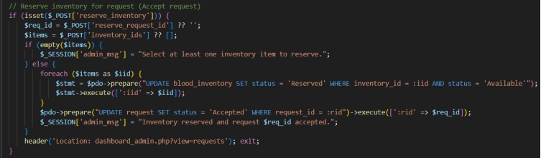
  - Reject request:
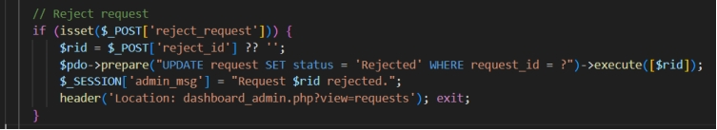
  - Assign employee to donor:
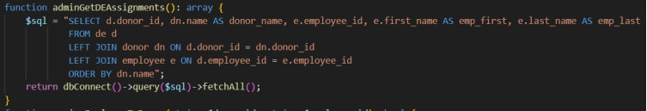
  - Get All users and all requests:
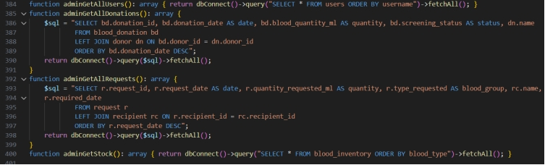

Report and analysis:
In this report, we demonstrate how to organize, analyze, and visualize data using Google Sheets. Google Sheets provides an intuitive platform for creating tables and generating graphs, allowing users to easily interpret and present data. By importing datasets and using built-in tools such as charts, pivot tables, and conditional formatting, we can highlight key trends, compare values, and summarize information effectively. This approach not only simplifies data management but also enables clear and professional reporting, making complex data more accessible and understandable for decision-making purposes.
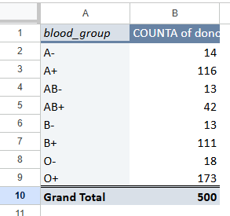
Count of donor_id for each blood group:
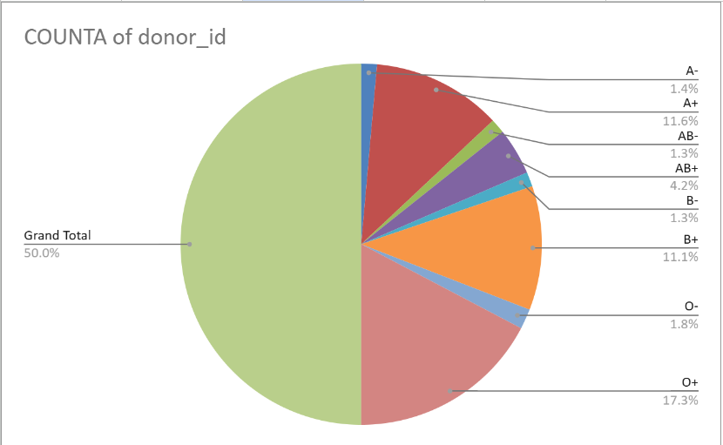
This data summarizes the distribution of blood groups based on the provided donor data.
Blood Group | Number of Donors | Percentage of Total
A- | 14 | 2.8%
A+ | 116 | 23.2%
AB- | 13 | 2.6%
AB+ | 42 | 8.4%
B- | 13 | 2.6%
B+ | 111 | 22.2%
O- | 18 | 3.6%
O+ | 173 | 34.6%
Grand Total | 500 | 100%
The data indicates a total of 500 donors. The most common blood group is O+, accounting for 34.6% of all donors, followed closely by A+ at 23.2% and B+ at 22.2%. The least common groups are AB- and B-, each accounting for just 2.6% of donors.
Count of location for each location:
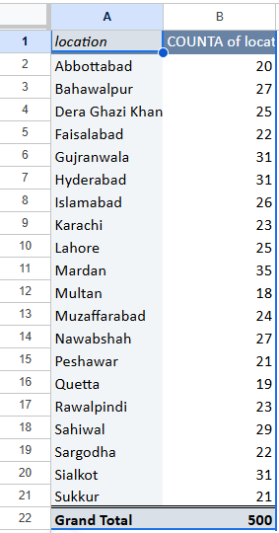
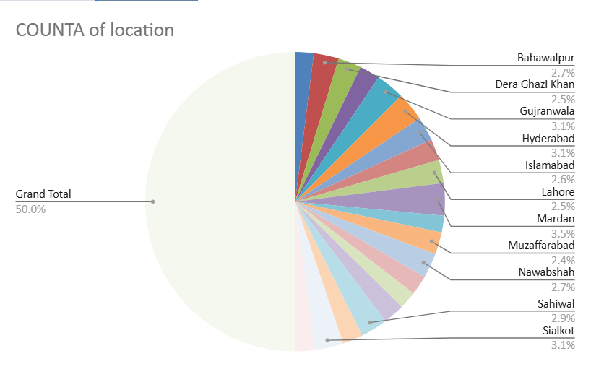

The provided data shows the distribution of a count across 21 different locations, totaling 500 entries.
Data Table Summary
Location | Count | Percentage of Total
Abbottabad | 20 | 4.0%
Bahawalpur | 27 | 5.4%
Dera Ghazi Khan | 25 | 5.0%
Faisalabad | 22 | 4.4%
Gujranwala | 31 | 6.2%
Hyderabad | 31 | 6.2%
Islamabad | 26 | 5.2%
Karachi | 23 | 4.6%
Lahore | 25 | 5.0%
Mardan | 35 | 7.0%
Multan | 18 | 3.6%
Muzaffarabad | 24 | 4.8%
Nawabshah | 19 | 3.8%
Peshawar | 23 | 4.6%
Quetta | 29 | 5.8%
Rawalpindi | 27 | 5.4%
Sahiwal | 22 | 4.4%
Sargodha | 31 | 6.2%
Sialkot | 31 | 6.2%
Sukkur | 21 | 4.2%
Grand Total | 500 | 100%

Key Observations
- Mardan has the highest count with 35 entries (7.0%).
- Multan has the lowest count with 18 entries (3.6%).
- Several locations share the same count, including Gujranwala, Hyderabad, Sargodha, and Sialkot, each having 31 entries.
- The data is visually represented in a pie chart, where each slice corresponds to a location and its proportional count.

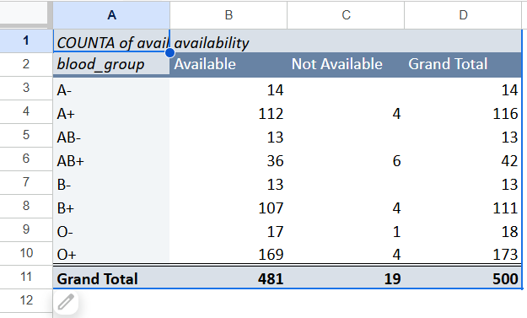
Count of availability for each blood group:
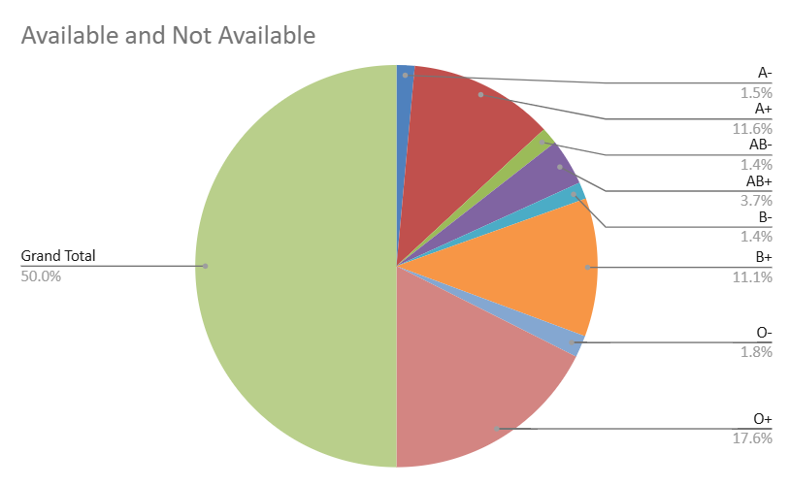
This data summarizes the availability status for various blood groups based on the provided data, which includes a summary table and a pie chart representation . A total of 500 records were analyzed.
Key Observations
- Out of 500 total instances, 481 were marked as Available, while 19 were Not Available.
- The O+ blood group has the highest count of available units at 169, making it the most frequent blood type in the sample.
- The A+ (112 available) and B+ (107 available) groups are also highly represented.
- The Not Available counts are very low across all groups, with AB+ having the highest number in this category (6).
Count of screening status:
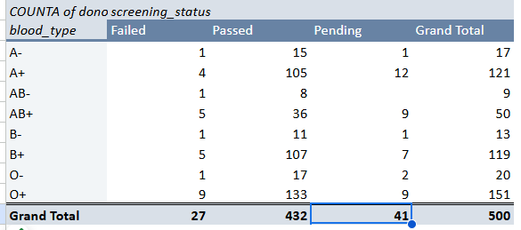
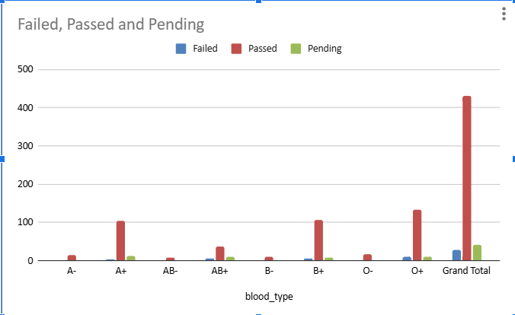
The key observations from the blood screening status report are:
- Total Donors: There are a total of 500 blood donors listed.
- Passed Status: The vast majority of samples, 432 out of 500, have successfully passed the screening process.
- Pending Status: There are 41 samples with a pending screening status.
- Failed Status: Only 27 samples have failed the screening process.
- Most Common Blood Type: Blood type O+ is the most common among donors, with 151 total samples.
- Least Common Blood Type: Blood type AB- is the least common, with only 9 total samples.
Sum of blood_quantity_ml for eacg group:
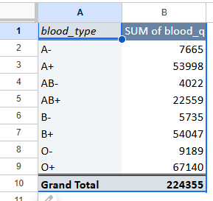
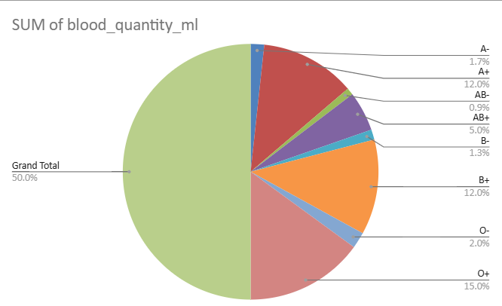
The key observation from the data is that blood type O+ has by far the largest total quantity of blood collected (224,355 ml), almost double the next highest, while AB- has the lowest quantity (4,022 ml).
Count of inventory_id, SUM of blood_quantity_ml for each status:
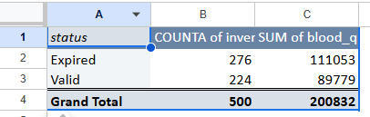
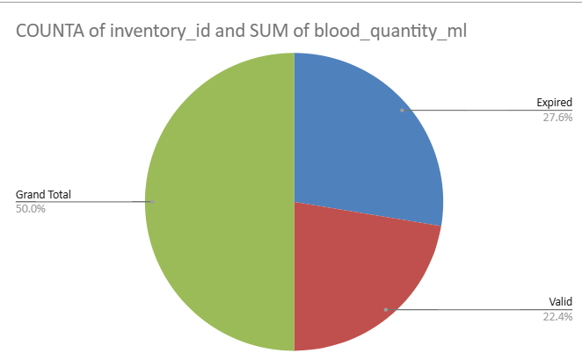
The key observation from the data is that blood type O+ has by far the largest collected volume (224,355 ml), almost double the next highest, while AB- has the lowest.
Sum of quantity_requested_ml for each facility_id by type_requested:
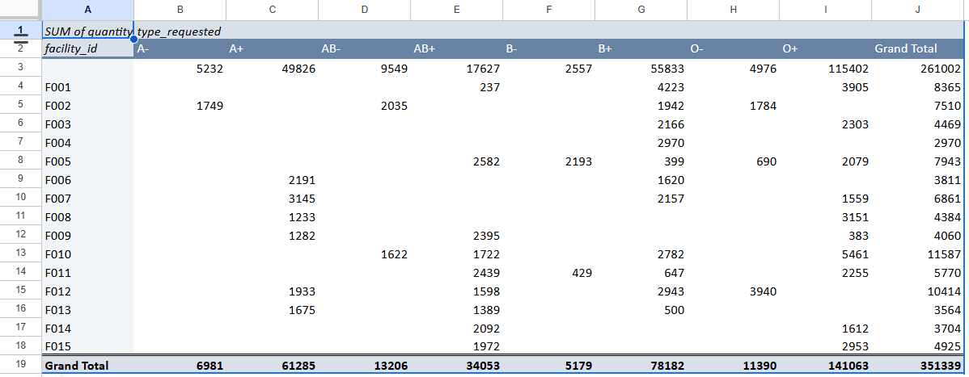
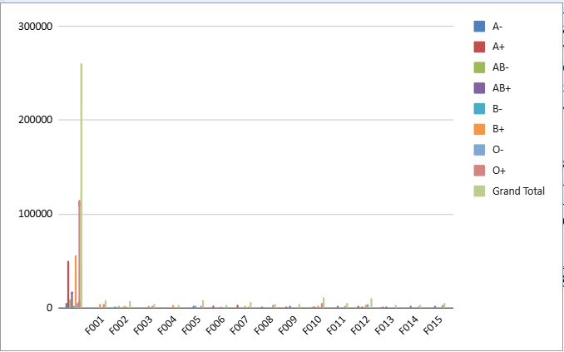
O+ (O positive) blood type is the most frequently requested type overall across the various facilities, based on the total quantity (ml) requested shown in the table. This aligns with general population data, which also indicates that O+ is one of the most common blood types.
Here are some additional key observations from the data:
- Dominance of O+: The 'Grand Total' row at the bottom shows O+ with the highest quantity requested (151,339 ml), significantly more than any other single blood type.
- Rh Positive Prevalence: Overall demand for Rh-positive blood types (A+, B+, O+, AB+) is substantially higher than for Rh-negative types (A-, B-, O-, AB-), a pattern consistent with general population distribution where Rh-positive individuals are more common.
- Universal Donor Demand: Type O- (universal donor) has a high demand relative to its lower prevalence in the population (total of 11,587 ml requested). This is likely due to its critical use in emergency transfusions when a patient's blood type is unknown.
- Rarest Types in Demand: AB- and B- are among the least requested blood types, which reflects their rarity in the general population.
- Facility-Specific Variation: While O+ is the overall leader, individual facilities show different primary demands. For example, facility F001 requested the largest amount of A+ (17,627 ml) among all facilities for that type, and a large quantity of B+ (55,833 ml). This indicates facility-specific patient needs or ordering practices.
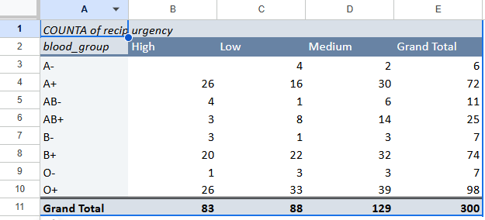
Count of recipient_id for each blood_group by urgency:
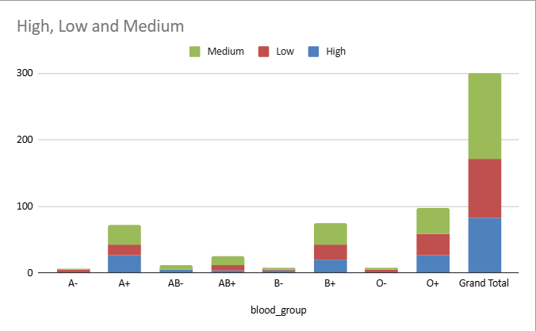
The data in the table, which is a contingency table, summarizes the count of recipients for each blood group by urgency level (High, Low, Medium). The key observation involves analyzing the frequencies to see if a particular blood group has a higher demand or urgency than others, or if the distribution of urgency levels is similar across all blood groups.
Key Observations
- O+ and A+ are the most common blood groups overall, with total recipient counts of 98 and 72, respectively, out of a grand total of 300 recipients.
- O+ has the highest number of "High" urgency recipients (26), but A+ has a similar number (26). O+ also has a high number of "Medium" urgency cases (39).
- A+ has the highest single cell count with 30 "Medium" urgency recipients.
- Blood groups O- and B- have the fewest recipients across all urgency levels.
- The total demand is highest for "Medium" urgency (129), followed by "Low" (88) and "High" (83) cases.
- The data can be used to determine if a recipient's blood group and their urgency level are associated or independent variables by calculating percentages or performing a chi-square test.
- These observations highlight the specific demands and distributions within the provided dataset.

Challenges
- Data Accuracy and Validation
  - Ensuring all donor and recipient data is correct and complete is critical to prevent mismatches.
  - Manual entry may lead to errors in blood group, contact information, or eligibility status.
- Inventory Management Complexity
  - Tracking blood units with varying expiry dates and quantities can be challenging.
  - Maintaining real-time availability while processing incoming and outgoing shipments requires careful database management.
- Compatibility Matching
  - Accurately finding compatible donors for recipients involves cross-checking blood types and Rh factors.
  - Incorrect matching could result in serious medical consequences.
- Shipment Handling Limitations
  - Basic shipment handling may not account for real-world logistics like temperature control or multi-location distribution.
- Scalability and Performance
  - As the number of donors, recipients, and blood units grows, queries and reports may slow down.
- Security and Access Control
  - Sensitive medical data must be protected against unauthorized access.
  - Admin controls need to be robust to prevent misuse.
- Web Interface Limitations
  - Basic HTML/CSS/PHP interfaces may be less user-friendly for large-scale operations.
  - Limited responsiveness could affect usability on mobile devices (even if mobile app is out of scope).

Improvements
- Enhanced Data Validation
  - Implement stricter checks on user input (e.g., blood group format, mandatory fields, age eligibility).
  - Use automated reminders for donors with expiring eligibility.
- Advanced Inventory Management
  - Include alerts for units nearing expiry.
  - Consider automated first-in-first-out (FIFO) allocation to reduce wastage.
- Improved Search and Reporting
  - Enable dynamic search filters for compatibility, location, and blood type.
  - Provide graphical dashboards for admin monitoring (availability trends, shipments, donor activity).
- Security Enhancements
  - Use SSL encryption for data transmission.
  - Implement role-based access control to restrict sensitive operations.
- User Interface Improvements
  - Enhance the UI using frameworks like Bootstrap for better responsiveness.
  - Provide clear feedback messages for actions (e.g., successful donation registration, shipment processed).
- Deployment and Going Live
  - Host the website on a web server (e.g., Apache, Nginx) with PHP and MySQL support.
  - Use platforms like cPanel hosting, DigitalOcean, or AWS for deployment.
  - Ensure proper domain setup and SSL certificate installation for secure access.
  - Configure backup schedules for the database to prevent data loss.
  - Test the live system thoroughly for performance, usability, and security

Conclusion
The Blood Donation Compatibility Tracking System is designed to centralize data, automate critical logic, and provide decision support using SQL-based operations. By integrating stored procedures, triggers, views, and analytical queries, the project efficiently demonstrates database principles with minimal frontend requirements. It also provides meaningful real-world benefits by making blood management more reliable and responsive.
…………………………………………………………………………………………………………………………………………….

